T34vsTiger Maya Exporter.

Tutorial 1.

Simple export.
- Copy Tools/MayaExp.mll from T23vsTider game folder to Maya plug-ins folder (like “C:\Program Files\AliasWavefront\Maya5.0\bin\plug-ins”).

- Open Maya 5.0 and create a simple primitive.
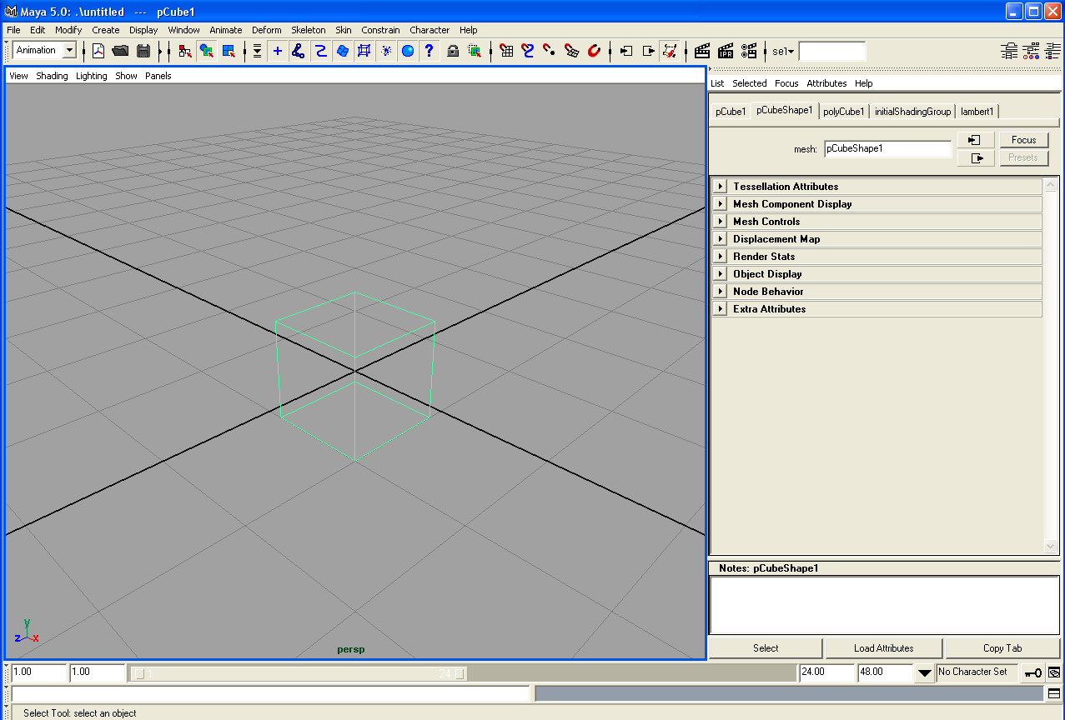
- Create new G5 shader material.
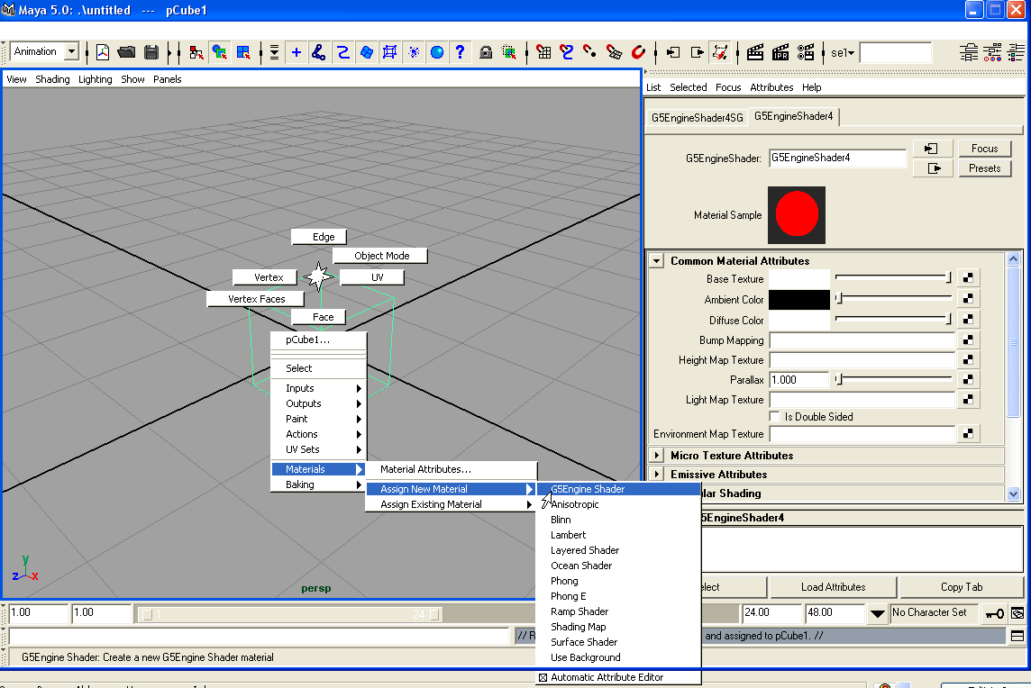
- Setup a texture.
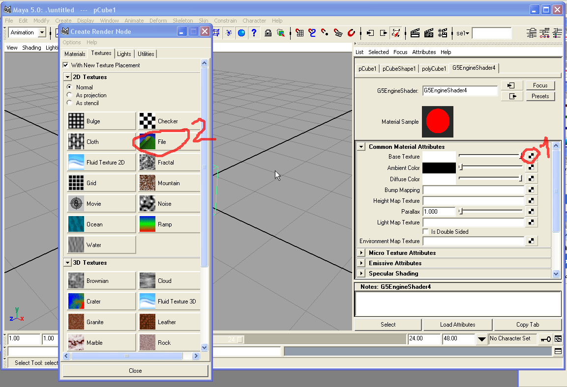
- Texture selecting.
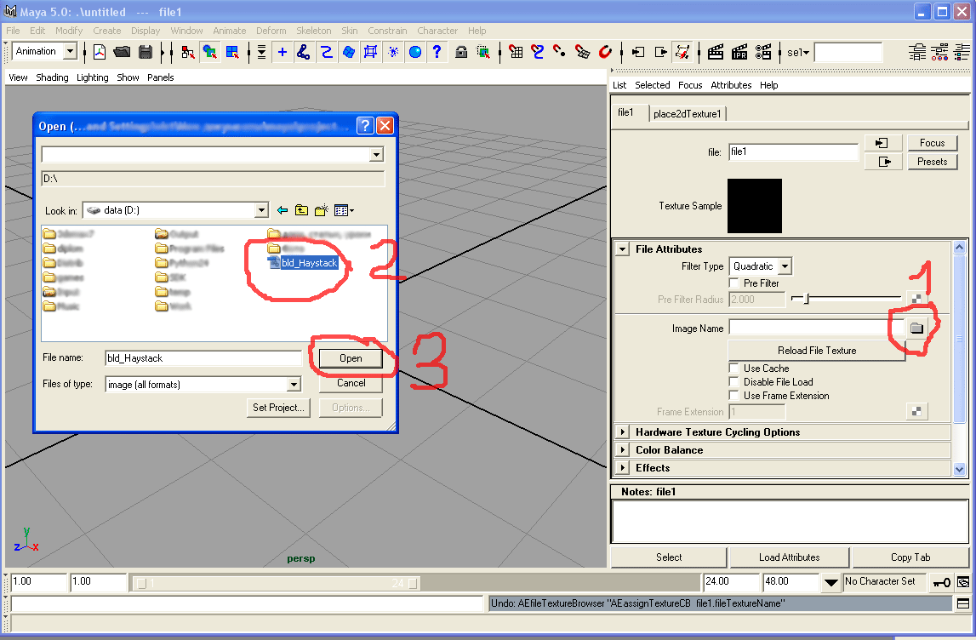
- Select Export All.
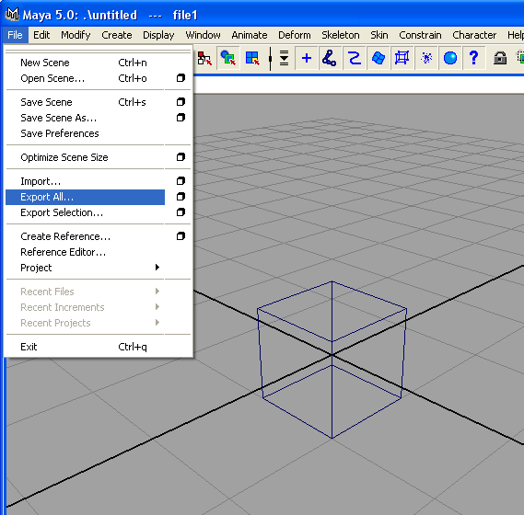
- Save to file.
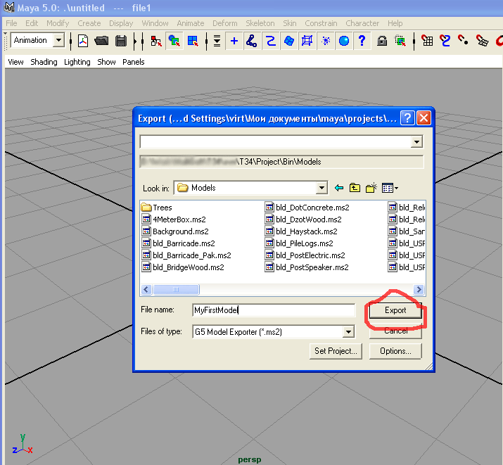
- Setup export settings.
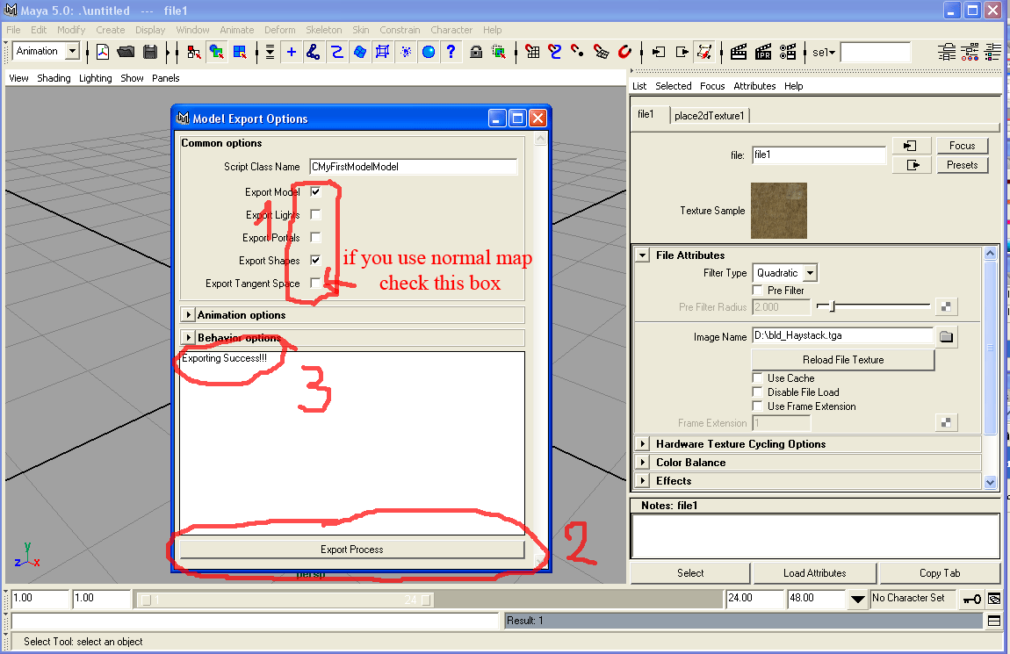
- Open G5 editor and you could see you model in the list.
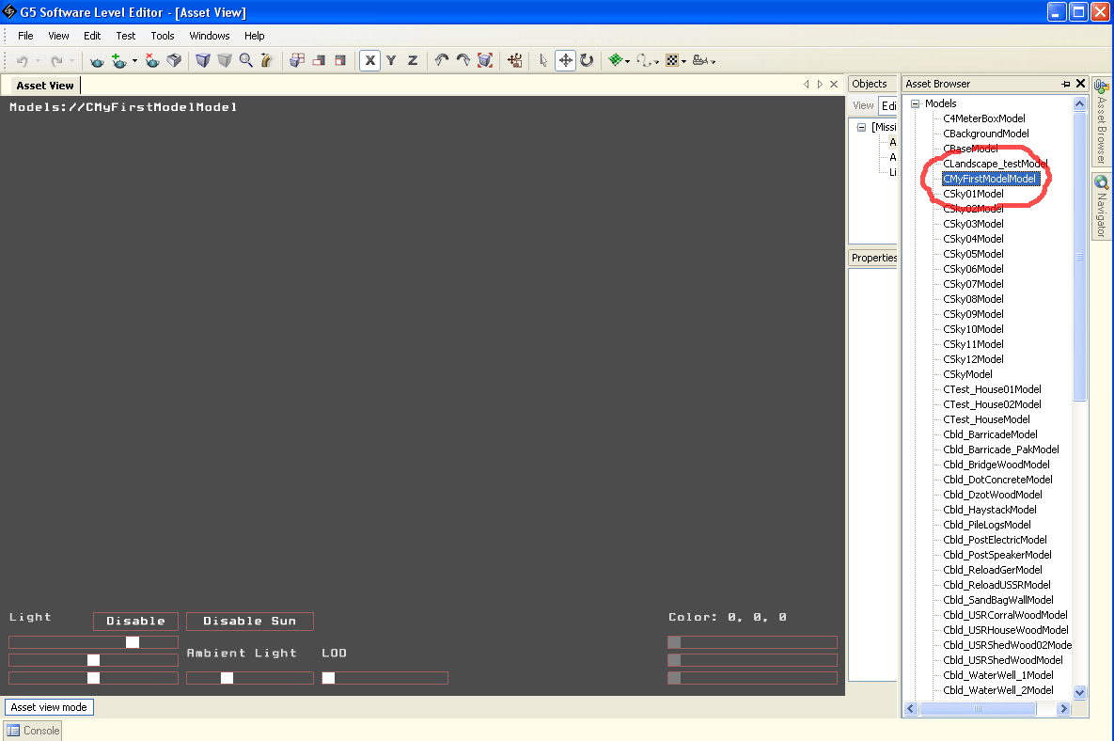
- Zoom out.
